**Task-3 : Multi-Cloud Architecture**

**DESIGN A MULTI-CLOUD ARCHITECTURE WHERE SERVICES ARE DISTRIBUTED ACROSS TWO CLOUD PROVIDERS**

**DELIVERABLE: A DOCUMENTATION AND DEMO SHOWCASING INTEROPERABILITY BETWEEN THE PLATFORMS**

Create a Instance

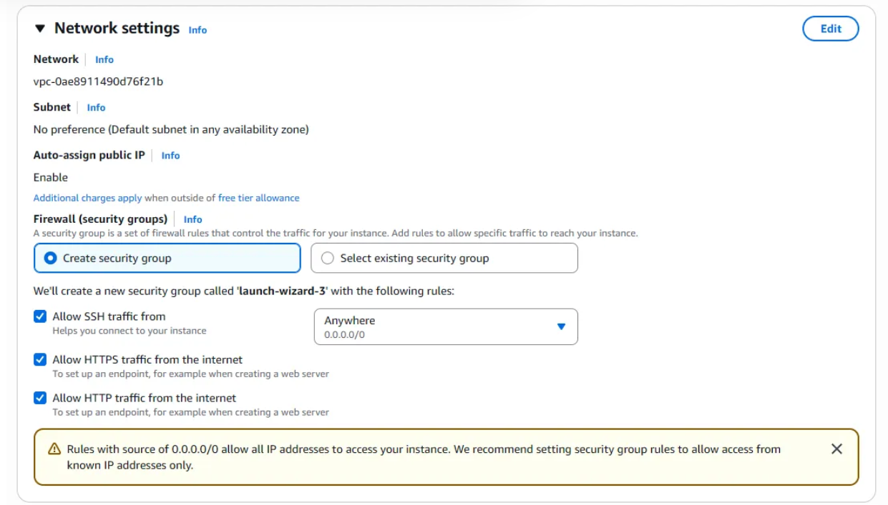

Here you must allow all network traffic

Connect to the Linux as admin by using “sudo su”

Now go to the azure portal this is the home page

First will create a Resource Group → Search Resource Group → click it

Then just give the name and Regions for it

* Name : MyResource
* Regions: (US) East US

Press create

Group is created

Go to Servers - Azure Arc → click it

Go to add a single server → Generate script

Give the subscription and resource group

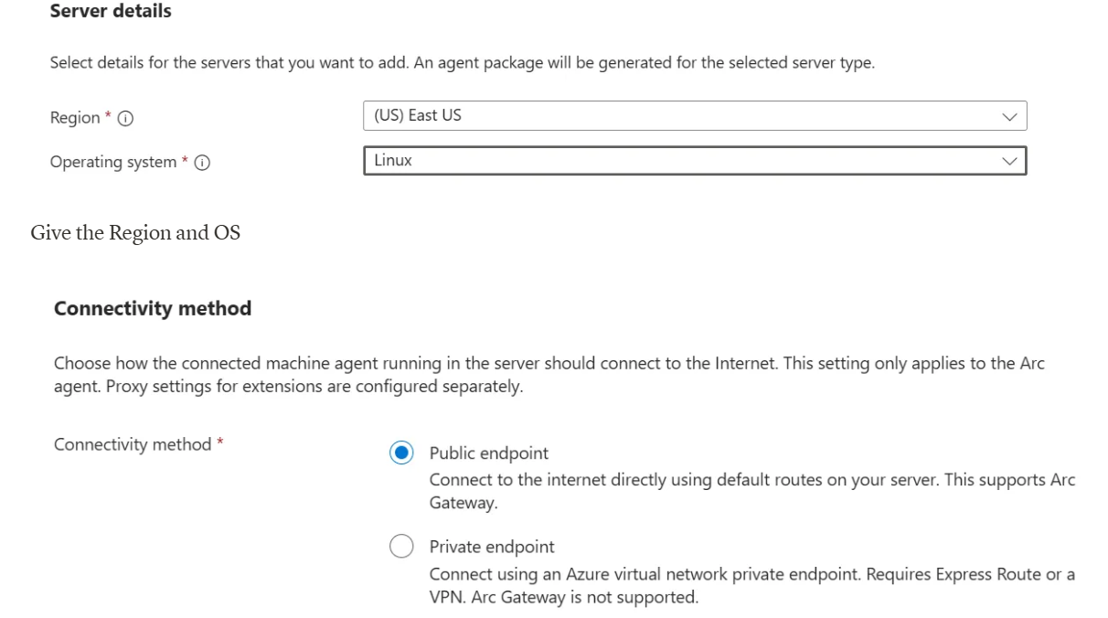

Keep the connectivity as Public

Keep this as default

Copy this code → go to aws Linux console

Type this

Paste the code here and save it

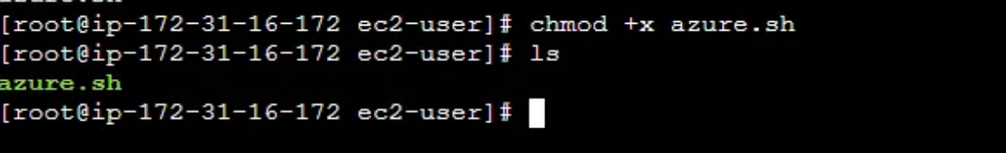

Execute the commands

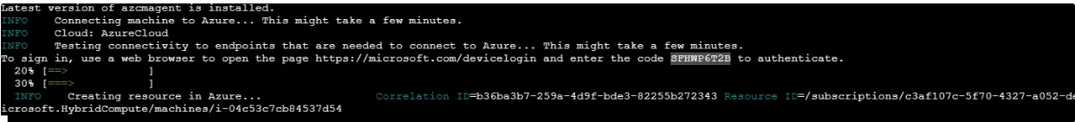

Copy the https browser link and past it in the browser tab (Note : don’t use shortcut to copy the link and code use mouse)

Paste the code given

Sign in to you azure account

Here azure Machine is connected

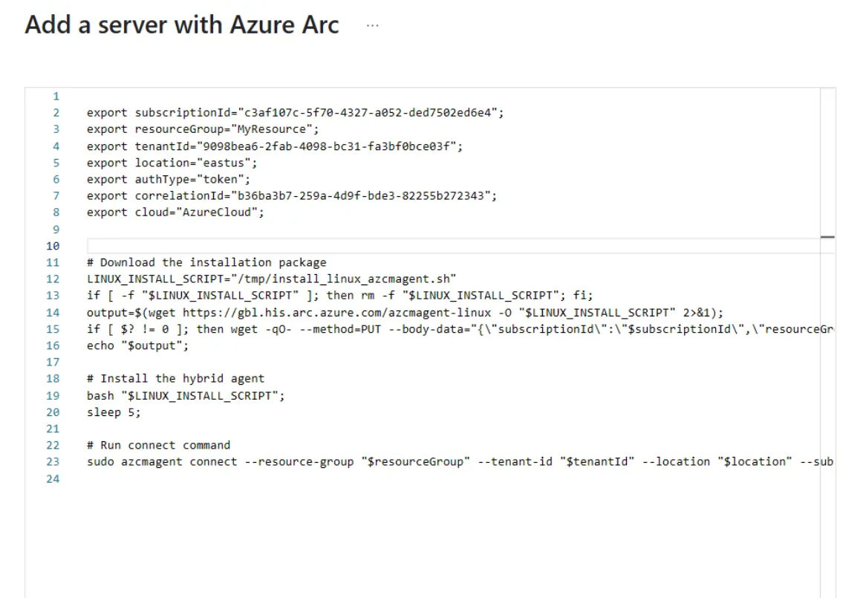

Close this → Go to home → Resource Group → click MyResource (Or what group you created)

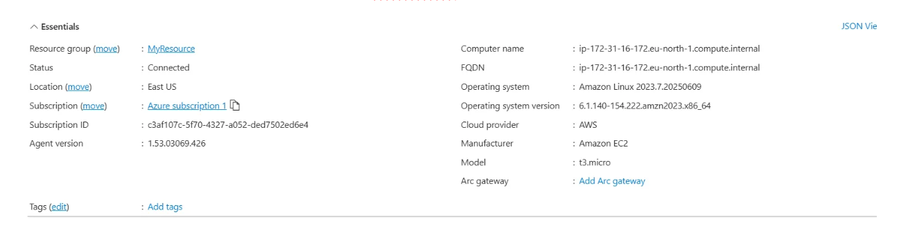

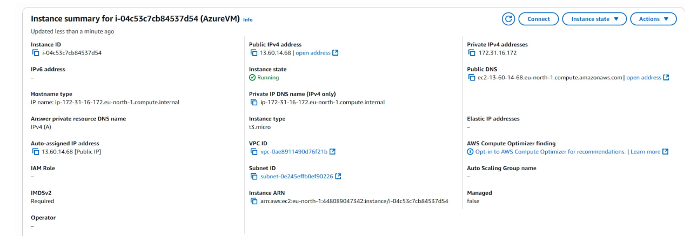

See the computer name will be having the same IP address in azure and Private IPv4 address in AWS

This is how to connect two cloud providers